Software Requirements Specification Template
CptS 322—Software Engineering
9 February 2005

The following annotated template shall be used to complete the Software Requirements Specification (SRS) assignment of WSU-TC CptS 322. The instructor must approve any modifications to the overall structure of this document.

Template Usage:
Text contained within angle brackets (‘<’, ‘>’) shall be replaced by your project-specific information and/or details. For example, <Project Name> will be replaced with either ‘Smart Home’ or ‘Sensor Network’.

Italicized text is included to briefly annotate the purpose of each section within this template. This text should not appear in the final version of your submitted SRS.

This cover page is not a part of the final template and should be removed before your SRS is submitted.

Acknowledgements:
Sections of this document are based upon the IEEE Guide to Software Requirements Specification (ANSI/IEEE Std. 830-1984). The SRS templates of Dr. Orest Pilskalns (WSU, Vancover) and Jack Hagemeister (WSU, Pullman) have also be used as guides in developing this template for the WSU-TC Spring 2005 CptS 322 course.

Retro Game Store

Software Requirements Specification

1.1

02.04.2024

Serhiy Budnik
Project manager

Revision History

Date | Description | Author | Comments
02.04.2024 | 1.1 | Serhiy Budnik

Document Approval

The following Software Requirements Specification has been accepted and approved by the following:
Signature | Printed Name | Title | Date
 | Serhiy Budnik | Projext manager

Table of Contents

Revision History ii
Document Approval ii
1. Introduction 1
1.1 Purpose 1
1.2 Scope 1
1.3 Definitions, Acronyms, and Abbreviations 1
1.4 Overview 1
2. General Description 2
2.1 Product Perspective 2
2.2 Product Functions 2
2.3 User Characteristics 2
2.4 General Constraints 2
2.5 Assumptions and Dependencies 2
3. Specific Requirements 2
3.1 External Interface Requirements 3
3.1.1 User Interfaces 3
3.1.2 Hardware Interfaces 3
3.1.3 Software Interfaces 3
3.5 Non-Functional Requirements 4
3.5.1 Performance 4
3.5.2 Reliability 4
3.5.3 Availability 4
3.5.4 Security 4
3.5.5 Maintainability 4
3.5.6 Portability 4
3.6 Inverse Requirements 4
3.7 Design Constraints 4
3.8 Logical Database Requirements 4
3.9 Other Requirements 4
4. Analysis Models 4
4.1 Sequence Diagrams 5
4.3 Data Flow Diagrams (DFD) 5
4.2 State-Transition Diagrams (STD) 5
5. Change Management Process 5

1. Introduction
The introduction to the Software Requirement Specification (SRS) document provides an overview of its contents. This document serves as a guide for software engineers to design and implement the Retro Game Store software. It contains all necessary information for this purpose.

1.1 Purpose
The purpose of this Software Requirement Specification (SRS) document is to outline the requirements for the design and implementation of the Retro Game Store software. It serves as a comprehensive guide for software engineers involved in the development process. Additionally, this document is intended to be utilized by project stakeholders, including developers, designers, testers, project managers, and clients, to ensure a clear understanding of the project scope and requirements.

1.2 Scope
(1) The software product to be produced is named the Retro Game Store platform.
(2) The Retro Game Store software will:
Provide a user-friendly interface for browsing, purchasing, and trading retro video games.
Allow users to create accounts, manage their profiles, and track their orders.
Enable administrators to manage inventory, user accounts, and website content.
Incorporate secure payment processing for transactions.
Support various features such as search functionality, wish lists, and recommendations.
The Retro Game Store software will not:
Provide physical delivery services for purchased games.
Offer services beyond the scope of retro video game sales and trading, such as digital downloads or hardware sales.
(3) The application of the Retro Game Store software includes: (a) Benefits, Objectives, and Goals: - Facilitate easy access to a wide range of retro video games for enthusiasts and collectors. - Enable users to discover, purchase, and trade retro games in a user-friendly online environment. - Provide a secure and reliable platform for transactions and user interactions. - Ensure timely and efficient order processing and delivery. - Offer personalized recommendations and features tailored to individual user preferences. (b) Consistency: - The scope outlined here aligns with similar statements in higher-level specifications, ensuring coherence across project documentation.

1.3 Definitions, Acronyms, and Abbreviations
Definitions:
Retro Game Store: Online platform for retro video game sales and trading.
User: Individual accessing Retro Game Store.
Administrator: Privileged user managing platform functions.
Inventory: Collection of available games.
Transaction: Process of purchasing or trading games.
Profile: User's personalized account information.
Acronyms:
SRS: Software Requirement Specification
DBMS: Database Management System
Abbreviations:
h: Hour

1.4 References
This subsection provides a complete list of all documents referenced elsewhere in the SRS, along with relevant details:
Title: IEEE Guide to Software Requirements Specifications Report Number: IEEE Std 830-1998 Date: 23 March 1998 Publishing Organization: Institute of Electrical and Electronics Engineers (IEEE) Source: Available from IEEE Digital Library (https://ieeexplore.ieee.org/)
Title: Retro Game Store Project Proposal Date: [Insert Date] Publishing Organization: [Insert Organization Name] Source: [Insert Source, e.g., Internal Document Repository]
Title: Retro Game Store System Requirement Specification (SRS) Appendix Date: [Insert Date] Publishing Organization: [Insert Organization Name] Source: [Insert Source, e.g., Internal Document Repository]
Additional documents referenced in the SRS may be listed in subsequent sections or referenced in appendixes within the document.

1.5 Overview
This subsection provides a summary of the contents and organization of the SRS:

(1) The rest of the SRS contains detailed information regarding the requirements, functionalities, and specifications of the Retro Game Store software. It outlines the scope of the project, including the objectives, features, and constraints. Additionally, it specifies user roles, system capabilities, and interface designs. The SRS also includes details on performance requirements, security considerations, and testing procedures.

(2) The SRS is organized into several sections, each focusing on specific aspects of the software requirements. These sections include:
- Introduction: Provides an overview of the document and its purpose.
- Scope: Defines the boundaries and objectives of the software product.
- Definitions, Acronyms, and Abbreviations: Lists the terminology used throughout the document.
- References: Provides a list of documents cited in the SRS.
- Overview: Describes the contents and organization of the SRS.
- Specific Requirements: Details the functional and non-functional requirements of the software.
- Appendices: Contains additional supporting information, such as mockups, diagrams, and supplementary documentation.

By following this organized structure, stakeholders can easily navigate the SRS to understand the complete set of requirements and specifications for the Retro Game Store software.

2. General Description
This section of the SRS outlines the overarching factors that influence the Retro Game Store software and its requirements. It provides context and background information to facilitate a better understanding of the subsequent specific requirements. It is important to note that this section does not contain specific requirements but rather sets the stage for their comprehension.

The General Description covers various aspects, including the purpose and goals of the Retro Game Store software, its intended audience, the business context in which it operates, and any constraints or limitations that may impact its development and implementation. Additionally, it may address technological considerations, such as compatibility requirements or integration with existing systems.

By presenting this broad overview, stakeholders gain a comprehensive understanding of the environment in which the Retro Game Store software will operate, allowing them to interpret specific requirements in context and make informed decisions throughout the development process..

2.1 Product Perspective

This subsection of the SRS provides context by positioning the Retro Game Store software within the broader landscape of related products or projects. It delineates how the Retro Game Store fits into the larger ecosystem of similar platforms, distinguishing its unique features and functionalities.

Additionally, this section may highlight any dependencies on external systems or interfaces, clarifying how the Retro Game Store interacts with other software or hardware components. It may also address interoperability considerations, outlining compatibility requirements with third-party services or industry standards.

By elucidating the product's perspective within its ecosystem, stakeholders gain insight into its role, relevance, and potential impact, facilitating effective decision-making and coordination throughout the development process.

2.2 Product Functions
This subsection of the SRS summarizes the primary functions that the Retro Game Store software will perform. It outlines the core capabilities and features that users can expect when interacting with the platform.

Key functions of the Retro Game Store software include:

1. User Registration and Authentication:
- Allow users to create accounts and log in securely.
- Authenticate user credentials to ensure access control.

2. Browsing and Searching:
- Provide a user-friendly interface for browsing the inventory of retro video games.
- Implement search functionality to allow users to find specific games based on various criteria.

3. Purchasing and Transactions:
- Enable users to add items to their cart and proceed to checkout for purchases.
- Integrate secure payment processing for transactions, ensuring confidentiality and integrity.

4. Inventory Management:
- Allow administrators to add, update, and remove games from the inventory.
- Track stock levels and manage product listings effectively.

5. User Profile Management:
- Enable users to view and edit their profiles, including personal information and preferences.
- Provide features for managing wish lists, order history, and saved preferences.

6. Recommendation System:
- Implement a recommendation engine to suggest games based on user preferences and browsing history.
- Personalize the user experience by offering tailored recommendations and suggestions.

7. Administration Dashboard:
- Provide administrators with a dashboard for managing user accounts, orders, and inventory.
- Allow administrators to view analytics and generate reports on platform activity.

By summarizing these functions, stakeholders gain a clear understanding of the core capabilities of the Retro Game Store software and its intended user experience..

2.3 User Characteristics

This subsection outlines the general traits of the Retro Game Store's user base, including:

1. Experience with Retro Gaming: Users vary in their familiarity with retro games.

2. Technological Proficiency: Users have different levels of comfort with technology.

3. Age and Demographics: The user base spans various age groups and demographics.

4. Preferences and Interests: Users have diverse gaming preferences and interests.

5. Usage Patterns: Users exhibit different patterns of platform usage.

6. Accessibility Needs: Consideration is given to users with accessibility requirements.

7. Language and Localization: The platform supports multiple languages and localization options.

Understanding these characteristics informs the design and development process to create a user-friendly experience tailored to diverse user needs.

2.4 General Constraints

This subsection of the SRS outlines any overarching limitations or constraints that may impact the design and development of the Retro Game Store software. These constraints serve as guidelines for the development team and influence decision-making throughout the project lifecycle.

Potential general constraints for the Retro Game Store may include:

1. Budgetary Constraints: The project must adhere to predefined budgetary allocations for development, maintenance, and operational costs

2. Time Constraints: The development timeline is limited, requiring adherence to deadlines for project milestones and delivery.

3. Technology Constraints: The software must be compatible with specific technologies or platforms, limiting the selection of development tools, frameworks, or programming languages.

4. Legal and Regulatory Constraints: The software must comply with relevant laws, regulations, and industry standards, such as data protection regulations or intellectual property rights.

5. Resource Constraints: Limited availability of human resources, hardware, or infrastructure may impact project scalability and resource allocation.

6. Security Constraints: The software must prioritize security measures to protect user data, transactions, and platform integrity against potential threats or vulnerabilities.

7. Performance Constraints: The software must meet specified performance criteria, such as response times, scalability, and system reliability, to ensure optimal user experience.

By identifying and acknowledging these general constraints upfront, the development team can proactively address challenges and make informed decisions to ensure the successful delivery of the Retro Game Store software within the specified constraints.

2.5 Assumptions and Dependencies
This subsection of the SRS lists factors that influence the requirements outlined in the document. These factors are not design constraints but can impact the requirements if they change. Examples include assumptions about hardware, software, or external dependencies.

Assumptions for the Retro Game Store may include:

1. Availability of Required Hardware: Assumes that necessary hardware, such as servers and network infrastructure, will be accessible for deployment.

2. Compatibility with Operating Systems: Assumes compatibility with specified operating systems, such as Windows, macOS, and Linux, for both server-side and client-side components.

3. Access to Third-Party APIs: Assumes continued access to third-party APIs for features like payment processing, geolocation services, or game recommendation engines.

4. Availability of Development Tools: Assumes availability and continued support for development tools, libraries, and frameworks used in the software development process.

Dependencies for the Retro Game Store may include:

1. Integration with Payment Gateways: Dependent on successful integration with selected payment gateways to facilitate secure transactions.

2. External Database Connectivity: Dependent on the availability and reliability of external databases for storing and managing inventory, user data, and transaction records.

3. Compliance with Regulatory Standards: Dependent on adherence to relevant regulatory standards, such as GDPR for data protection and PCI DSS for payment security.

4. Availability of Internet Connectivity: Dependent on stable internet connectivity for users to access the Retro Game Store platform and perform online transactions.

By documenting these assumptions and dependencies, the development team can anticipate potential changes or challenges and adjust the requirements accordingly to ensure the successful development and deployment of the Retro Game Store software.

3. Specific Requirements

Understood. This section will focus on detailing the specific requirements for the Retro Game Store software. Each requirement will adhere to the following criteria:

- Correctness: Accurately represents the desired functionality or behavior of the software.

- Traceability: Can be linked back to customer requirements and forward to design, implementation, and testing artifacts.

- Unambiguity: Clearly and precisely defines the intended functionality without room for misinterpretation.

- Verifiability: Testable through verification and validation processes.

- Priority: Prioritized based on importance and stability, ensuring focus on critical features.

- Completeness: Covers all necessary functionalities and behaviors expected from the software.

- Consistency: Does not conflict with other requirements and maintains coherence throughout the document.

- Uniqueness: Identified uniquely, typically through numbering, for easy reference and tracking.

Careful organization will ensure ease of access and understanding of the requirements presented in this section. It's important to note that while this SRS guides the software design, implementation, and testing, it should not overly constrain or dictate the software architecture. Let's proceed with detailing the specific requirements for the Retro Game Store software in accordance with these guidelines.

3.1 External Interface Requirements
1. User Interfaces:
- Web Interface: An intuitive, responsive web-based interface designed for effortless browsing and purchasing of retro games on the retro game store website. Users can easily explore the catalog, view game details, and complete transactions seamlessly.

2. Hardware Interfaces:
- Payment Terminal Integration: Implementation of a hardware interface that enables secure communication with payment terminals. This integration ensures that customers can make payments for their retro game purchases safely and efficiently, whether in-store or via a mobile point-of-sale system.

3. Software Interfaces:
- Database Management System (DBMS): Integration with a compatible DBMS for streamlined storage and management of data related to the retro game inventory and customer information. This integration optimizes data handling processes, facilitates inventory management, and enhances customer relationship management.

4. Communication Interfaces:
- API Integration: Secure integration with external APIs for various services, particularly payment processing and other relevant functionalities. This API integration enables seamless communication and data exchange between the retro game store's systems and external service providers, such as payment gateways and delivery service companies, ensuring smooth operations and enhancing user experience.3.1.1 User Interfaces

3.1.2 Hardware Interfaces
1. Payment Terminal Integration:
- Support for secure communication with payment terminals.
- Enables in-person transactions in physical stores, if applicable.
- Facilitates real-time transaction processing and inventory updates.

3.1.3 Software Interfaces
1. Database Management System (DBMS):
- Integration with a compatible relational database management system (DBMS) for data storage and management.
- Ensures compatibility with popular systems like MySQL, PostgreSQL, or Microsoft SQL Server.
- Enables efficient retrieval, storage, and manipulation of data related to inventory, user accounts, and transactions.

3.1.4 Communications Interfaces
1. API Integration:
- Secure integration with external APIs for various functionalities such as payment processing, shipping, and game recommendation engines.
- Utilizes standard authentication methods like OAuth 2.0 for secure data exchange.
- Enables seamless communication with external services to enhance the functionality of the Retro Game Store platform.

3.2 Functional Requirements
1. User Account Management - Registration, login, and profile management functionalities for users.
2. Game Browsing and Searching - Browse and search features for users to find and explore retro games.
3. Cart and Checkout - Cart management and secure checkout process for users to purchase games.
4. Inventory Management - Adding, updating, and removing game listings for administrators.
5. Order Management - Order history, processing, and tracking functionalities for users and administrators.
6. Recommendation System - Personalized game recommendations and featured game displays.
7. Administration Dashboard - User management, inventory analytics, and reporting tools for administrators.

3.5 Non-Functional Requirements
3.5.1 Performance:
- Ensure responsive user interface with fast loading times for browsing and searching games.
- Handle concurrent user interactions efficiently to prevent system slowdowns during peak usage.

3.5.2 Reliability
- Ensure stable operation of the platform with minimal downtime or service interruptions.
- Implement error handling and recovery mechanisms to handle unexpected failures gracefully.

3.5.3 Availability
- Aim for high availability of the Retro Game Store platform, with uptime exceeding 99%.
- Implement redundancy and failover mechanisms to minimize service disruptions in case of hardware or software failures.

3.5.4 Security
- Implement robust security measures to protect user data, transactions, and platform integrity.
- Utilize encryption protocols for secure communication and storage of sensitive information.
- Implement access controls and authentication mechanisms to prevent unauthorized access to system resources.

3.5.5 Maintainability
- Design the software with modular and well-documented code to facilitate ease of maintenance and future updates.
- Implement logging and monitoring functionalities to facilitate troubleshooting and debugging.
- Adopt coding standards and best practices to ensure code quality and readability.

3.5.6 Portability
- Ensure compatibility with multiple web browsers and operating systems to reach a broader user base.
- Design the software architecture to be platform-independent, allowing for easy deployment on various hosting environments.
- Minimize dependencies on specific hardware or software configurations to enhance portability across different environments.

3.6 Inverse Requirements
- Users should not experience excessive latency or delays when browsing or searching for games.
- The platform should not allow unauthorized access to user accounts or sensitive information.
- Transactions should not be processed if payment information is incomplete or invalid.

3.7 Design Constraints
- Compliance with GDPR regulations regarding data privacy and protection.
- Adherence to company policies regarding branding, user experience, and security protocols.
- Compatibility with existing hardware infrastructure, including server specifications and network configurations.

3.8 Logical Database Requirements
- Yes, a relational database management system (DBMS) will be used.
- Requirements include:
- Support for storing game inventory, user profiles, and transaction records.
- Data formats compatible with the chosen DBMS (e.g., SQL for relational databases).
- Storage capabilities to handle expected data volume and growth.
- Data retention policies to ensure compliance with legal and regulatory requirements.
- Implementation of data integrity constraints, such as unique constraints and foreign key relationships, to maintain data consistency.

3.9 Other Requirements
- Integration with third-party APIs for payment processing, shipping, and game recommendation services.
- Support for multiple languages and localization options to accommodate users from diverse regions.
- Implementation of backup and disaster recovery mechanisms to protect against data loss and system failures.
- Compatibility testing across various web browsers and devices to ensure a consistent user experience.

4. Analysis Models

4.1 Sequence Diagrams
- Sequence diagrams illustrate the interactions between different components or actors in the system over time.
- They show the sequence of messages exchanged between objects or processes, along with any conditions or loops.
- Sequence diagrams can be used to visualize the flow of control and data in scenarios such as user interactions, system operations, or transaction processing.
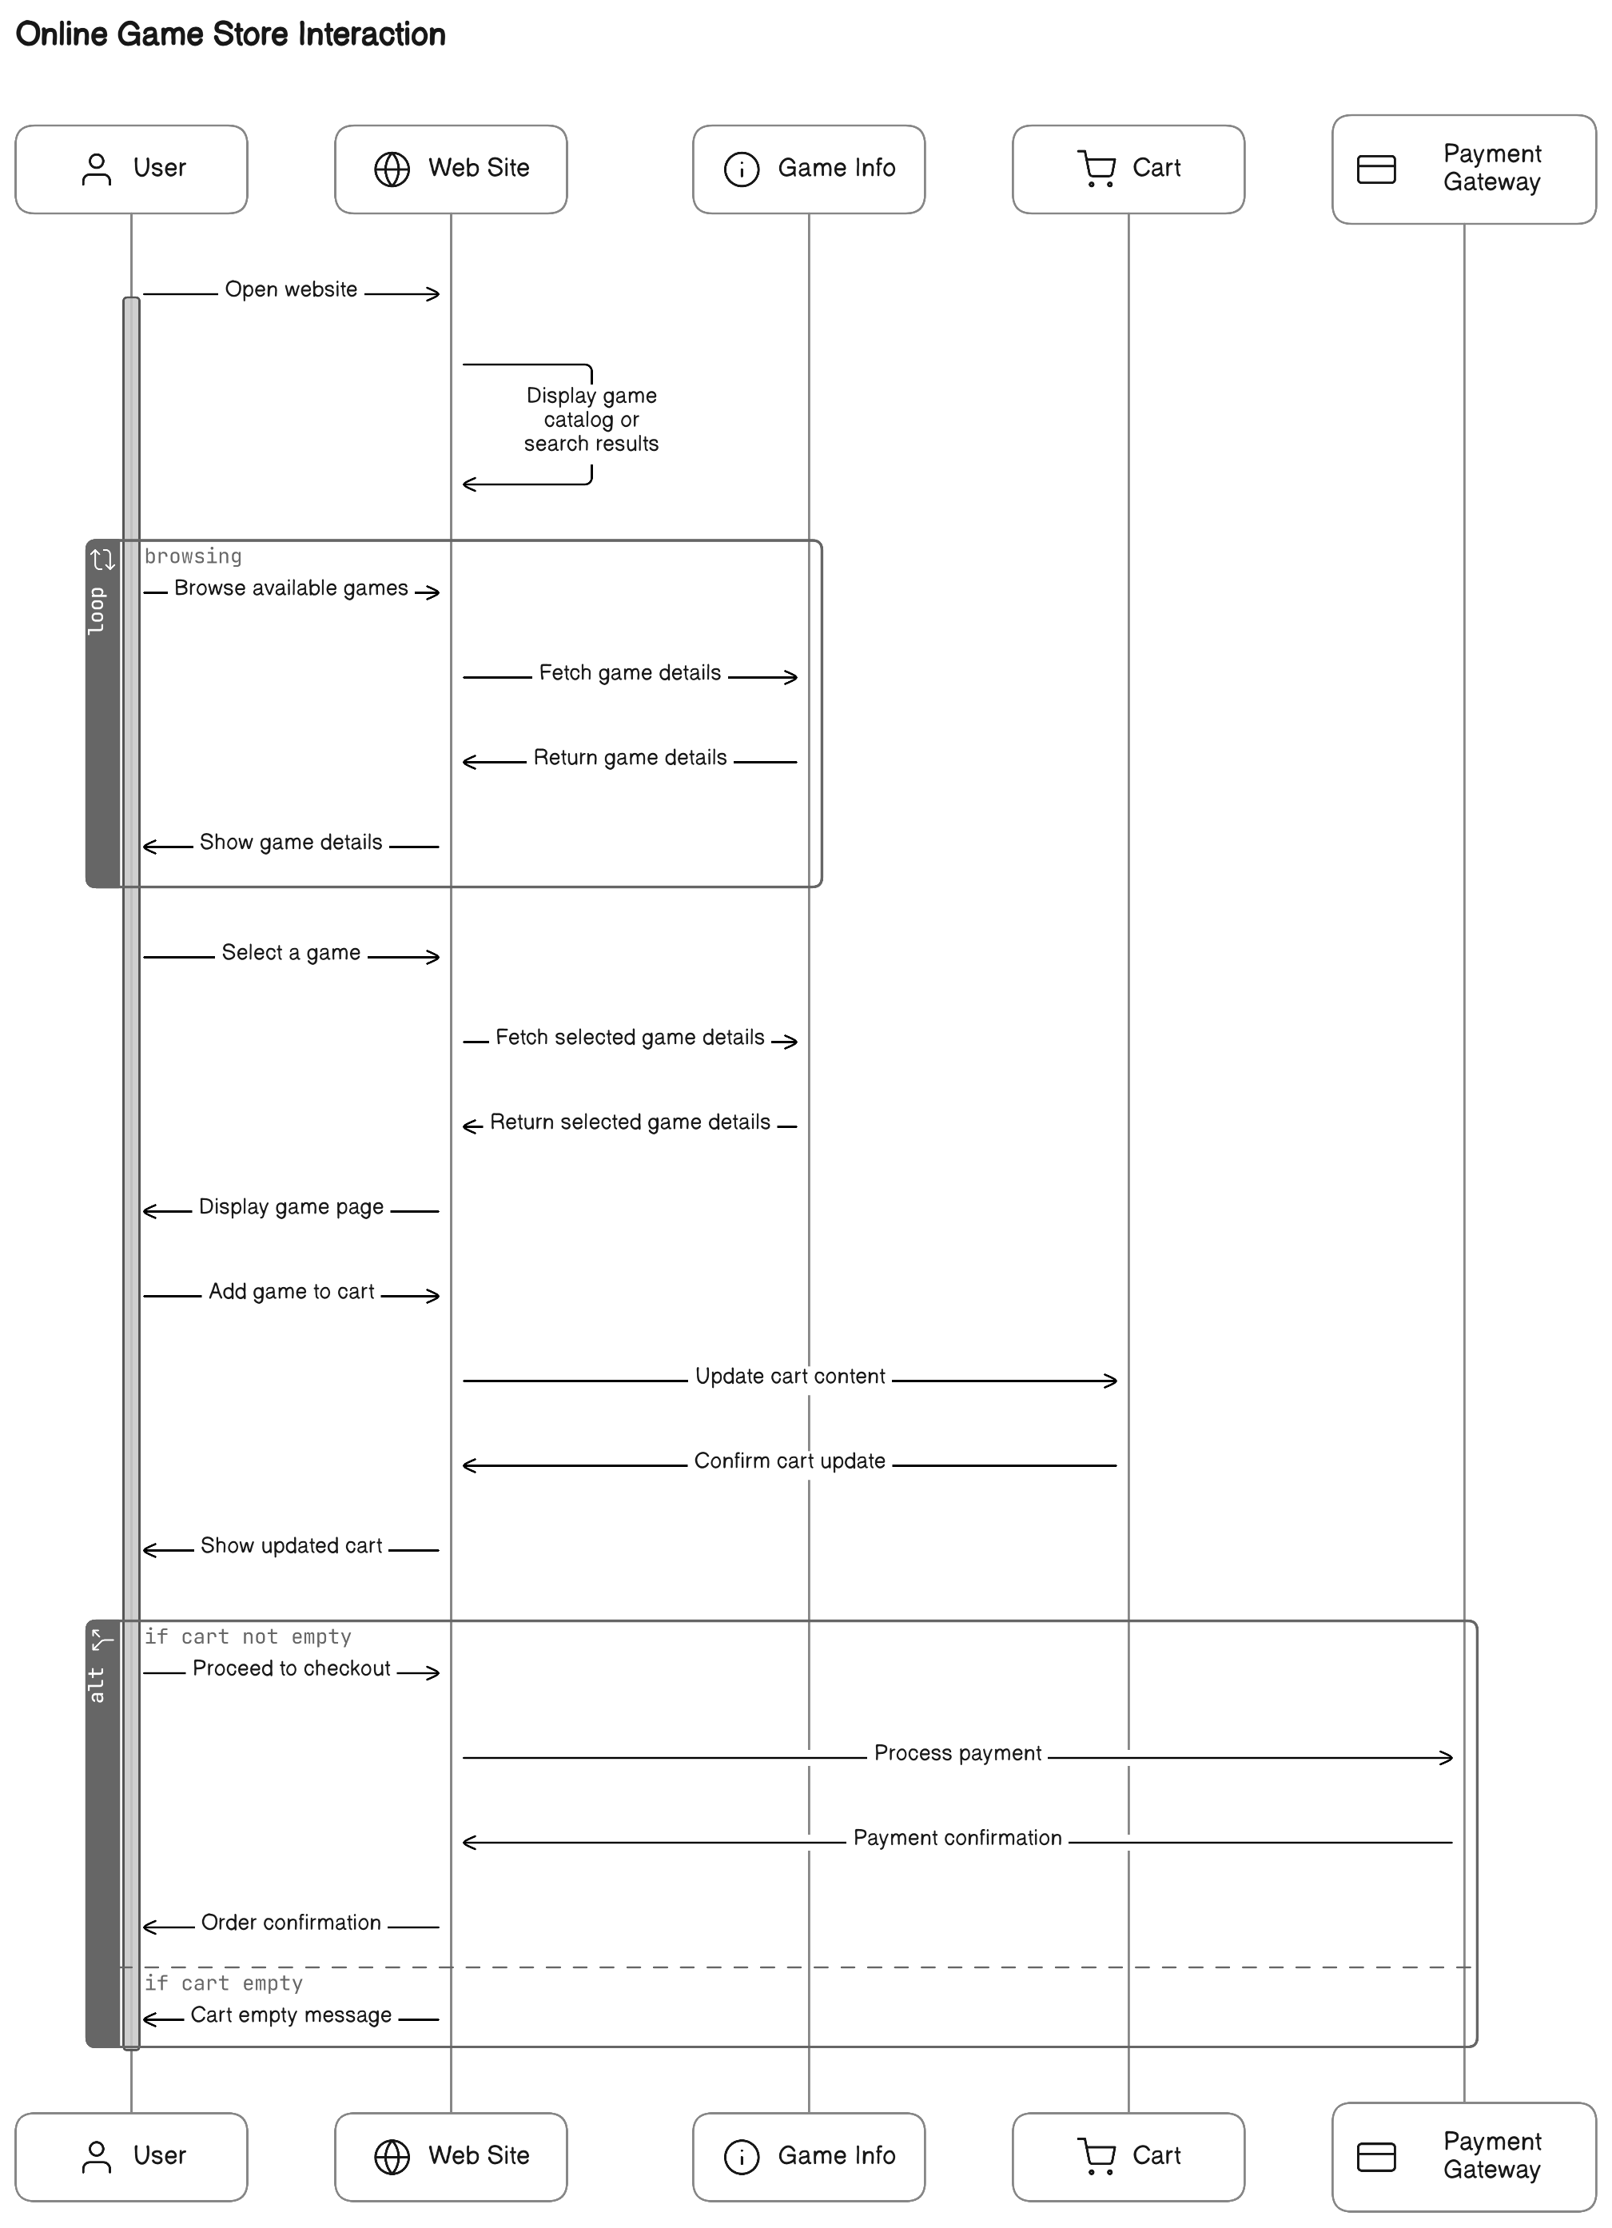
4.2 State-Transition Diagrams (STD)
- State-transition diagrams depict the various states that an object or system can be in and the transitions between those states.
- They show how the system's behavior changes in response to external events or stimuli.
- State-transition diagrams are useful for modeling the dynamic behavior of systems, such as user interfaces, process workflows, or control systems.
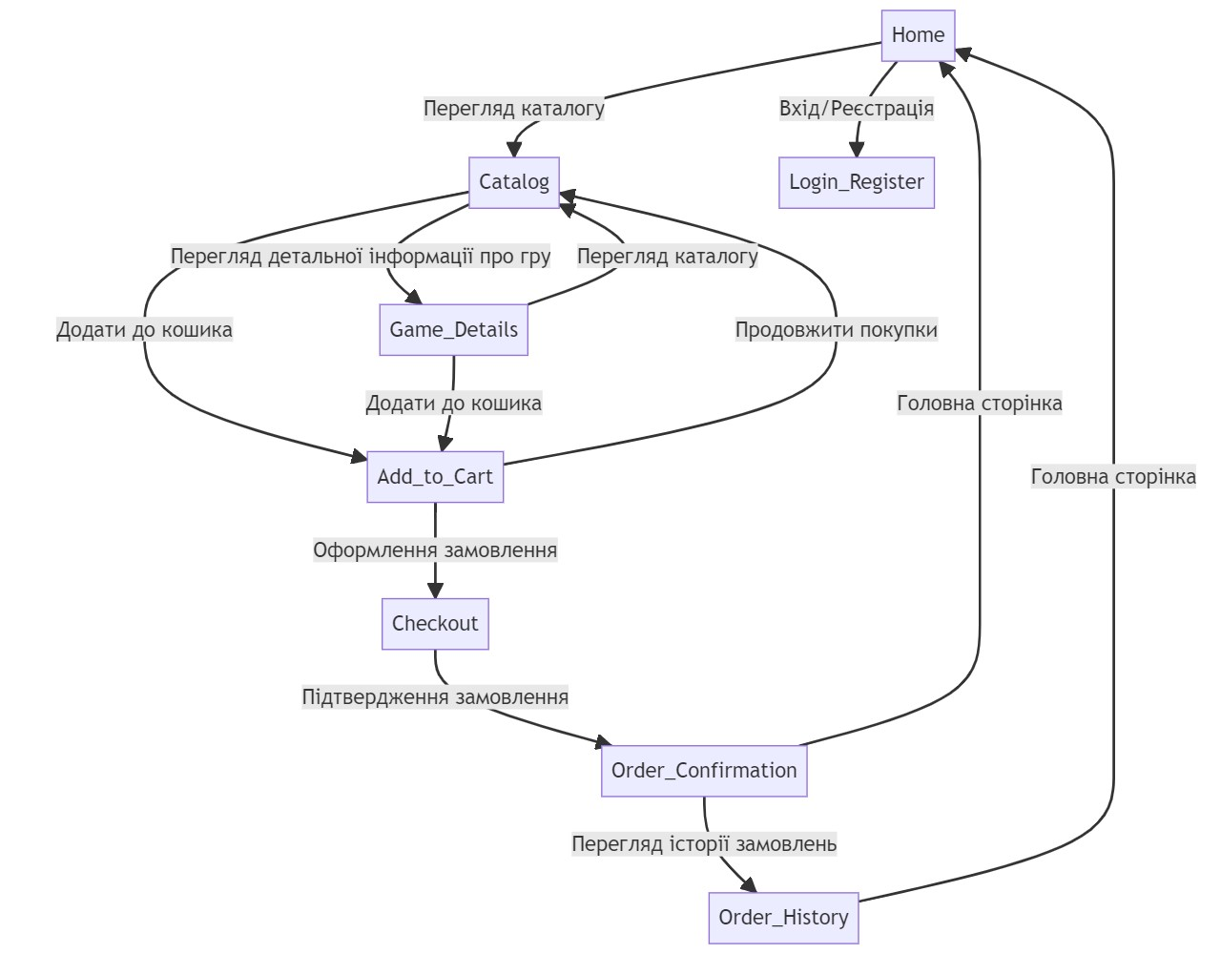
4.3 Data Flow Diagrams (DFD)
- Data flow diagrams represent the flow of data within a system, showing how data moves between processes, stores, and external entities.
- They consist of processes that transform data, data stores where data is stored, and data flows that represent the movement of data between processes and stores.
- Data flow diagrams are used to visualize the structure and flow of information in systems, helping to identify data sources, processing steps, and data destinations.
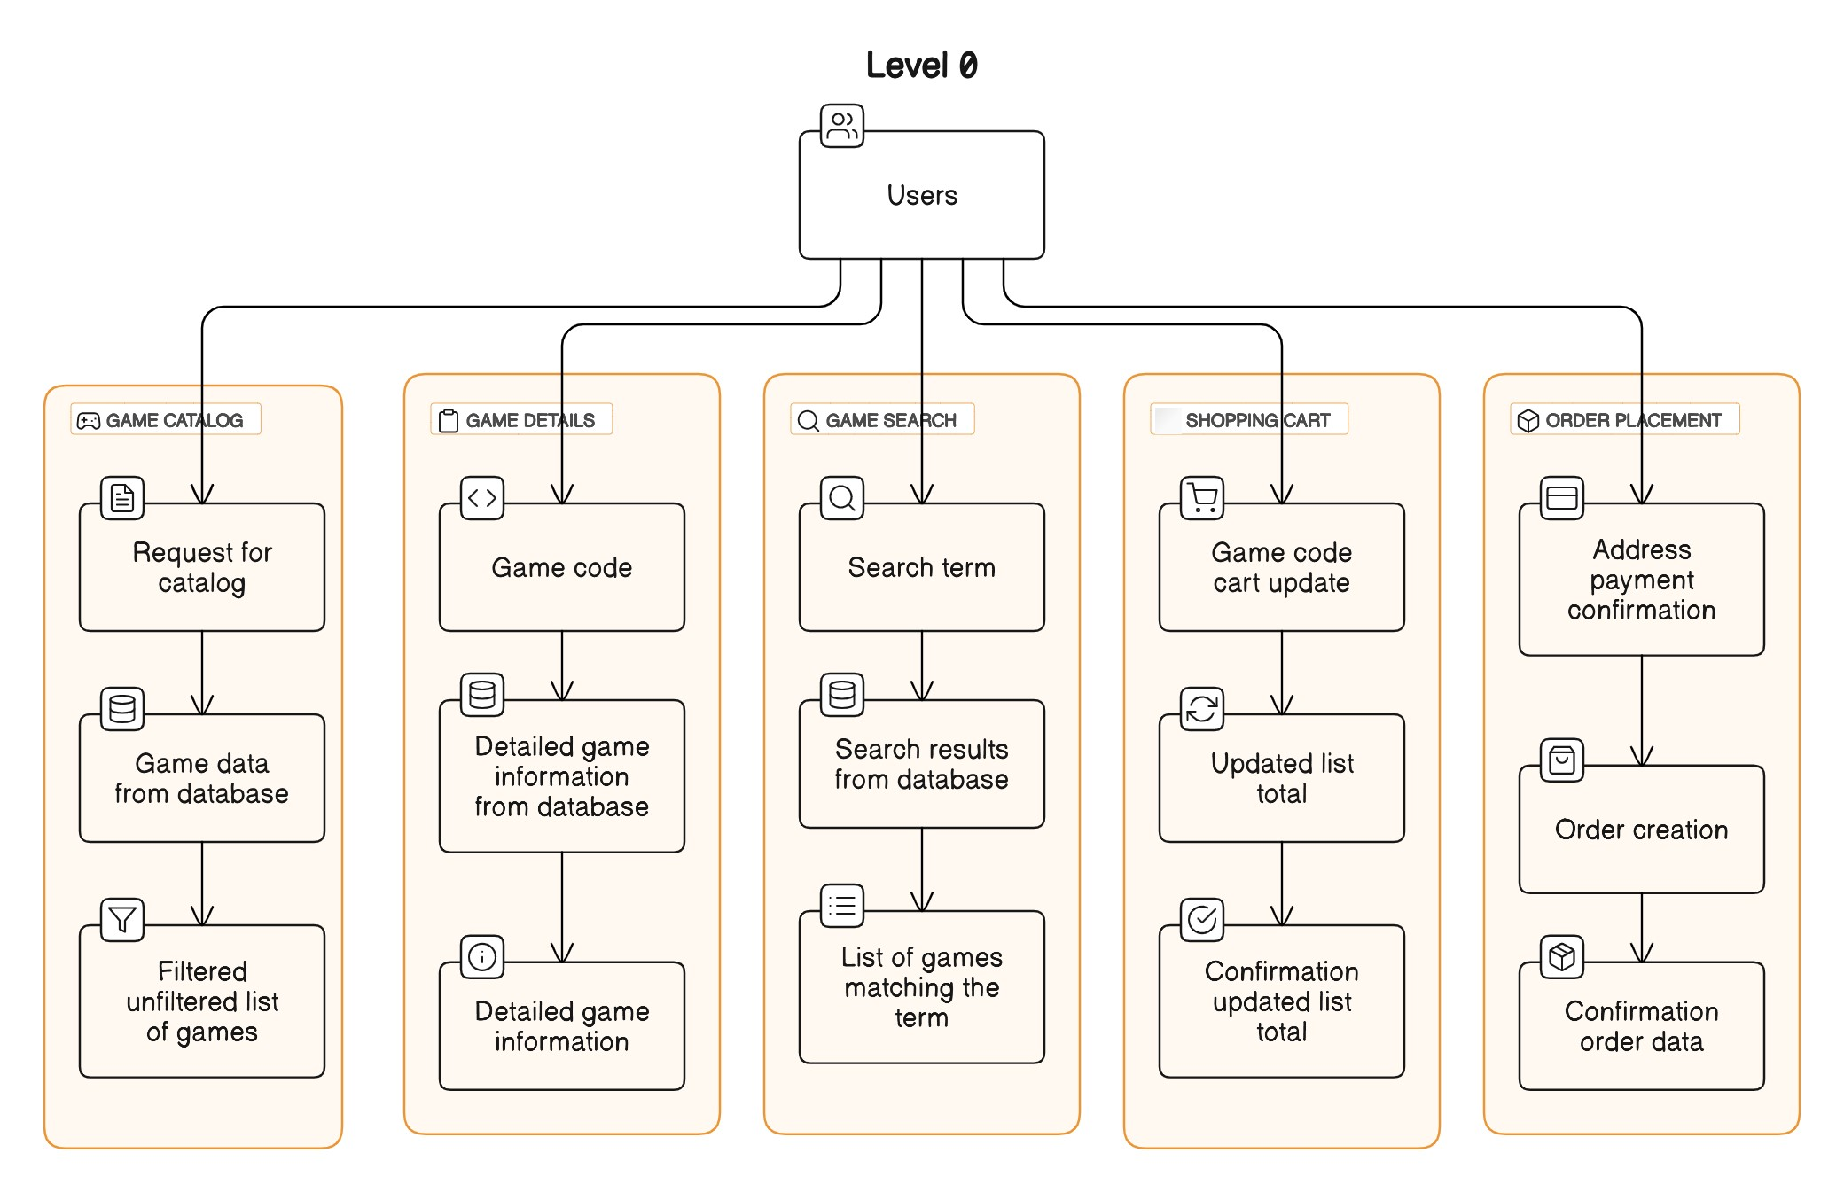

5. Change Management Process
Change Management Process for Updating the SRS:

Submission of Changes:
- Any stakeholder, including project managers, developers, testers, or clients, can submit proposed changes to the SRS.
- Changes can be submitted through designated channels, such as email, project management tools, or change request forms.

Review and Evaluation:
- Upon receiving a change request, the project manager or designated authority will review the proposed changes.
- The review process may involve assessing the impact of the proposed changes on project scope, timeline, budget, and resources.

Analysis and Documentation:
- The project team will analyze the proposed changes to determine their feasibility, implications, and necessity.
- Changes that are approved will be documented, detailing the specific modifications to the SRS and their rationale.

Approval Process:
- Approved changes to the SRS will undergo a formal approval process.
- The project manager or designated authority will review and approve the proposed changes based on their alignment with project goals, requirements, and constraints.
- For significant changes that may impact project scope or deliverables, approval may require consensus from key stakeholders, including clients or project sponsors.

Documentation Update:
- Once approved, the updated SRS will be revised to incorporate the approved changes.
- The changes will be documented clearly and comprehensively, ensuring that all stakeholders are informed of the modifications.

Communication:
- Communication channels will be used to inform all relevant stakeholders about the approved changes to the SRS.
- Project team members, clients, and other stakeholders will be notified of the updated requirements and any associated implications for project planning and execution.

Version Control:
- A version control system will be utilized to track revisions to the SRS and maintain a history of changes.
- Each updated version of the SRS will be systematically labeled and archived to ensure traceability and accountability.

By following this change management process, the SRS can be updated efficiently and effectively to reflect evolving project scope or requirements while ensuring alignment with project objectives and stakeholder expectations.

